Deep Learning - Logistic Regression

Homework 1

In linear regression we model our data with a linear function which outputs continuous values :

f(w,b) = wx +b

However, when we talk about logistic regression we are not interested in continuous values but we want probabilistic values. In order to plot predicted values into probabilities between 0 and 1, we use the sigmoid function to plug it into our linear function.

 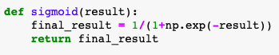

From these assumptions we can see the hypothesis of logistic regression. 

Then we have to apply this logistic regression function over the summation of weights features:



Later on, we had to define the cost function(0.5) :



We can now calculate the accuracy and loss of each data and update the weights in each epoch and batches:



After our training data is finished, we can check the accuracy and the loss of our logistic regression program:

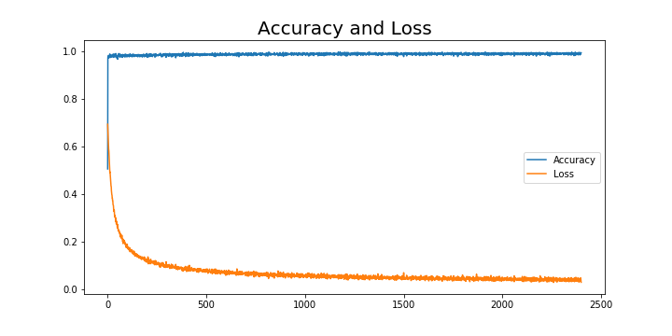

As we can see from my results above, my calculated average accuracy was: 0.9879, average loss was: 0.0697